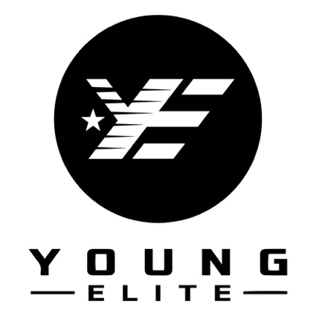

Company: Young-Elite Clothing
Department: Fashion Marketing & Branding
Employment Type: Part time (1 to 2 days)
Location: London, UK (Office is based within Kings Cross and Hammersmith)

Overview of Project
Young-Elite Clothing was created out of love for the positive and inspiring vibe of uplifting people to be the best they can be! When creating this fashion brand, one of main objectives was to inspire people with authenticity while being mindful of designing a high-end style at affordable costs.
We found passion to channel our life experiences and vision into styling people with a different edge and concept to the fashion plus inspirational space while allowing artistic mastery to flow free.
Our inspiration has always been to be a brand for positive vibes and stay true to our culture, motivating people to mirror their beliefs that are kept near to their hearts as they become their best versions. We candidly trust that clothing enhances individuality as we provide people a trendy way to have fun but also unique, exclusive and confident.
Duties
We are recruiting for a professional fashion marketing assistant to join our team. The ideal candidate will have a deep understanding of the fashion industry, a creative mindset, and a proven track record in developing and executing successful marketing campaigns. As a Fashion Marketing Manager, you will be responsible for creating and implementing marketing strategies that enhance brand awareness, drive sales, and foster customer loyalty. You will work closely with the design, sales, and digital teams to ensure that our marketing efforts are aligned with our overall business goals. Your role will involve analysing market trends, identifying target audiences, and leveraging various marketing channels to reach and engage customers. You will also be responsible for managing budgets, overseeing the production of marketing materials, and measuring the effectiveness of campaigns. The successful candidate will be a strategic thinker with excellent communication skills and the ability to thrive in a fast-paced, ever-changing environment. If you are passionate about fashion and have a knack for marketing, we would love to hear from you.

As a Fashion Marketing Assistant , your primary roles may include:

- Developing and implement comprehensive marketing strategies for fashion brands.
- Collaborate with design and sales teams to align marketing efforts with business goals.
- Analyse market trends and consumer behaviour to identify opportunities.
- Manage and allocate marketing budgets effectively.
- Oversee the production of marketing materials, including advertisements, brochures, and digital content.
- Plan and execute marketing campaigns across various channels, including social media, email, and events.
- Monitor and measure the effectiveness of marketing campaigns.
- Build and maintain relationships with media, influencers, and other industry partners.
- Conduct market research to stay updated on industry trends and competitor activities.
- Develop and maintain a strong brand identity and ensure consistency across all marketing materials.
- Coordinate with external agencies and vendors for marketing projects.
- Create and manage content for the company's website and social media platforms.
- Organize and participate in promotional events and trade shows.
- Prepare and present regular reports on marketing activities and results.
- Ensure compliance with all marketing regulations and industry standards.

